DESIGN
As with the previous projects, this project was a good exercise in applying the lessons from JavaFX, combined with proper validation of user-inputted data. For the most part, I followed along with the general recommendations in the project description, however, I added in some additional items that were not listed as requirements. I added validation of user input, and the display of an error message if invalid input was detected. I also converted all the inputted units for distance, gasoline cost, and gas mileage to Imperial units so that I could minimize math errors.

UML
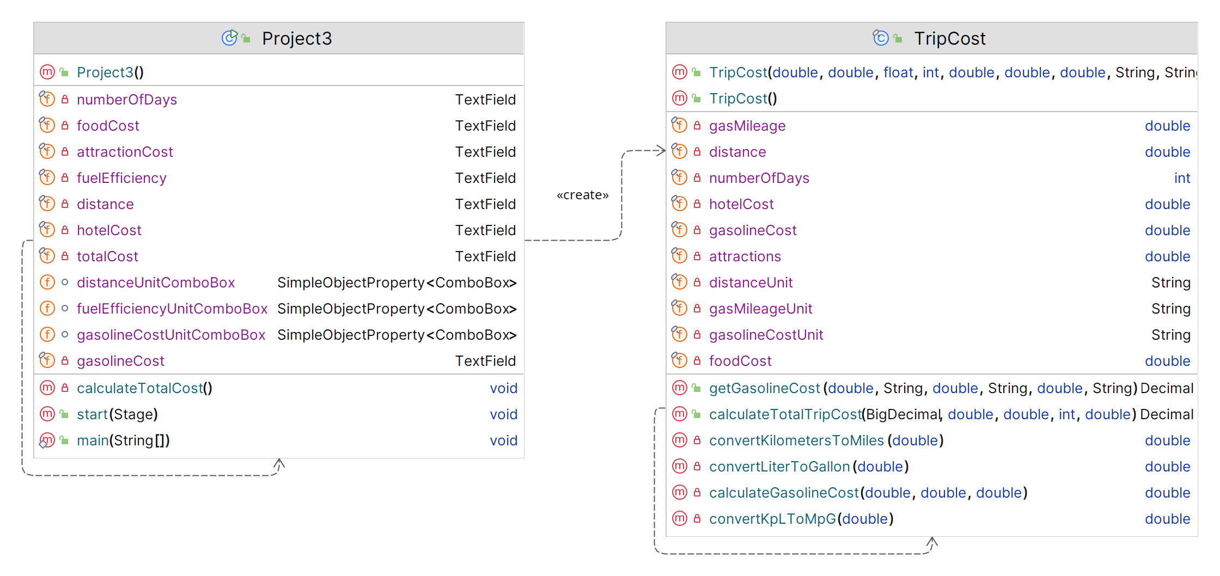

TEST PLAN
Test # | Input |  |  | Expected Output
1 | Distance: | 1000 | Miles | Validate that output matches requirements document  Total Cost: $755.42
1 | Gasoline Cost | 3.95 | Dollars/Gal
1 | Gas Mileage | 31 | Miles/Gal
1 | Number of Days | 2
1 | Hotel Cost | 150
1 | Food Cost | 125
1 | Attractions | 78
2 | Distance: | 1000 | Kilometers | Changing distance unit from Miles to Kilometers and Gas Mileage from MPG to KPL provides sane results  Total Cost: $814.24
2 | Gasoline Cost | 3.95 | Dollars/Gal
2 | Gas Mileage | 31 | Km/L
2 | Number of Days | 2
2 | Hotel Cost | 150
2 | Food Cost | 125
2 | Attractions | 78
3 | Distance: | 1000 | Kilometers | Provide non-numerical values for several fields. Program shoujld replace fields that contain non-numerical values with “Numbers only please”. Fields with numerical values should be retained.
3 | Gasoline Cost | 3.95 | Dollars/L
3 | Gas Mileage | 31 | Km/L
3 | Number of Days | Apple
3 | Hotel Cost | Banana
3 | Food Cost | Cherry
3 | Attractions | Date
4 | Distance: | 1130 | Miles | Sample trip to Orlando theme park, based on current fuel cost and MPG.  Total Cost: $6474.65
4 | Gasoline Cost | 3.64 | Dollars/Gal
4 | Gas Mileage | 33 | Miles/Gal
4 | Number of Days | 7
4 | Hotel Cost | 250
4 | Food Cost | 300
4 | Attractions | 2500
5 | Distance: | 1820 | Kilometers | Sample trip to Orlando theme park, based on current fuel cost as with #4, but using kilometers for distance and KPL for gas mileage.  Total Cost: $7041.62
5 | Gasoline Cost | 3.64 | Dollars/Gal
5 | Gas Mileage | 14 | Km/L
5 | Number of Days | 7
5 | Hotel Cost | 250
5 | Food Cost | 300
5 | Attractions | 2500

SCREEN SHOTS
1
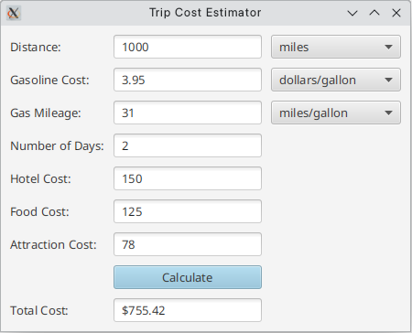
2
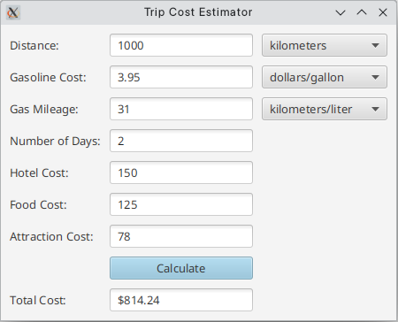

3
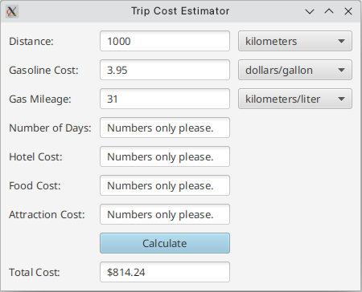
4
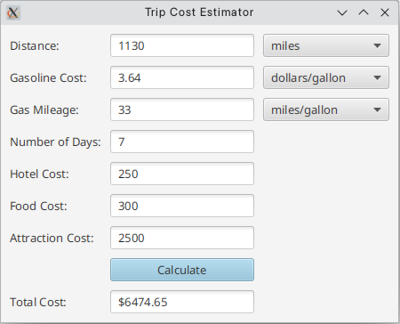
5
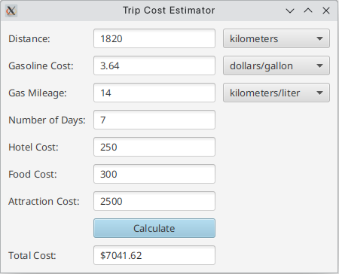

LESSONS LEARNED
Some specific items that the project reinforced were:
Always validate user input.
Do not lose valid input when possible – clear invalid fields but keep valid data
Double check math for unit conversions – preferably, always convert to a single unit to perform calculations, no matter what the source unit.

